# Database Restore Document

Below steps needs to followed while restore the database.

* Open Microsoft SQL Server Management studio.
* Right click Databases node, select Restore Database.
* Once done, restore window will get popped up.

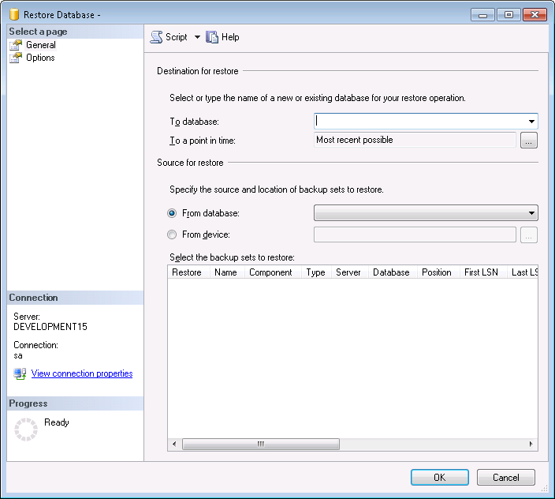

* In the To Database part, select in which database it has to be restored.
* Select From Device option to select the backup file.
* Click browse button to select backup file.
* Once clicked browse button, below window get popped up.

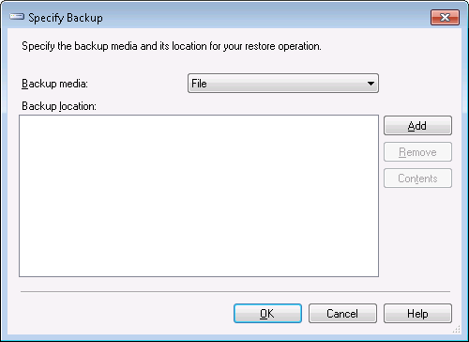

* Select Add button to select backup file.
* Once clicked the add button, backup file window will be popped up.

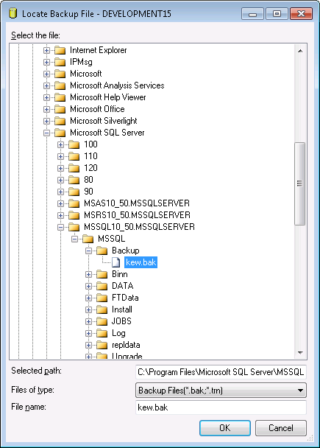

* Select the backup file and click Ok.
* The selected file will displayed under restore column.

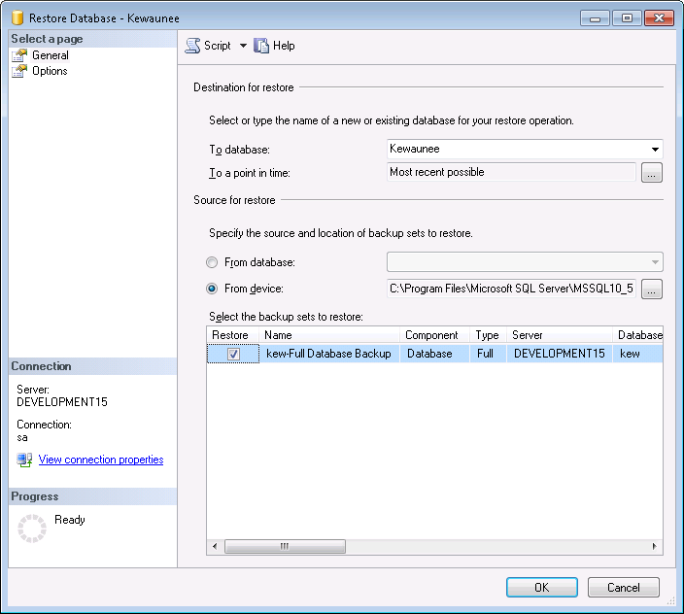

* Click Restore check box and click Ok to restore the database.
* Once done the database will be added under databases node.